Performance Testing Report

1. Project Information
Project Name: _____CRYPTOFLUX_________
Student Names: __Syed Waqar Ali__, ___Ali Asadullah Shah_, __Muhammad Mustansir_
Student Roll Nos: __24k-8301____, _24k-8324__, __24k-8305______
Date: __02nd May 2026_

2. System Overview
Describe the system under test:
CryptoFlux is a web-based automated cryptocurrency trading bot. The system under test includes the frontend interface (HTML/JS) currently hosted locally via VS Code Live Server, which communicates with backend Python APIs for market data and trade execution.

3. Objectives of Performance Testing
- Successfully simulate real-world traffic using Apache JMeter.
- Evaluate the system's response time, throughput, and error rate under varying user loads (10, 50, and 100 users).
- Compare the performance of different endpoints (Home, Market, News).

4. Test Environment
Hardware: Core i7, 11th Generation, 32 GB Ram, 1024 SSD
Software: Windows 11, VS Code Live Server, Apache JMeter 5.6.3, Java 11.
Network: Localhost (127.0.0.1:5500)

5. Workload Model
Users: Ranging from 10 to 100 simulated users (Threads).
Transactions: HTTP GET requests to core frontend files.
Duration: 10-second ramp-up period with 3 loop iterations.

6. Test Scenarios
Basic Load Test & Stress Testing
Scenario | Description | Expected Outcome
10 Users | Mild load accessing the Home page. | Instant response, 0% errors.
50 Users | Moderate load accessing the Home page. | Fast response, 0% errors.
100 Users | Heavy load accessing the Home page. | Slight delay, identifying if errors begin.

7. Metrics
- Response Time
- Throughput
- Error Rate

8. Results

Results (Home Page Endpoint)
Scenario | Average Response Time (ms) | Throughput (Req/sec) | Error Rate (%)
Load Home 10 Users | 5 ms | 3.3/sec | 0.00%
Load Home 50 Users | 6 ms | 3.9/sec | 0.00%
Load Home 100 Users | 6 ms | 5.1/sec | 0.00%
Load Market (20 Users) | 4 ms | 6.3/sec | 0.00%
Load News (20 Users) | 5 ms | 6.3/sec | 0.00%

Task 1 : Basic Load Test 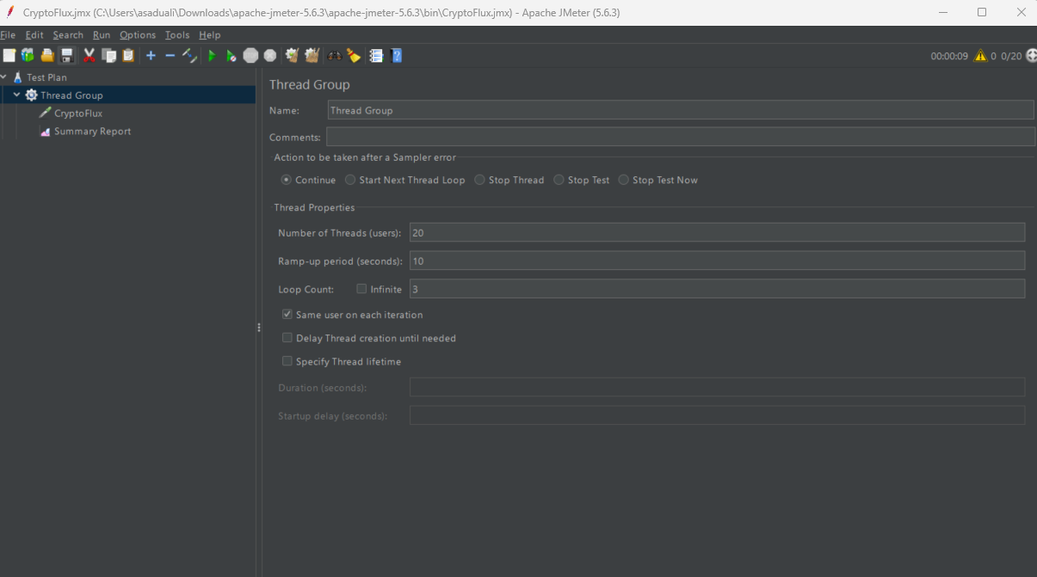
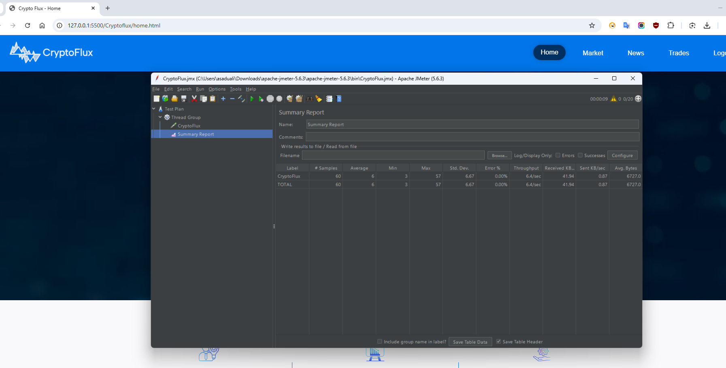
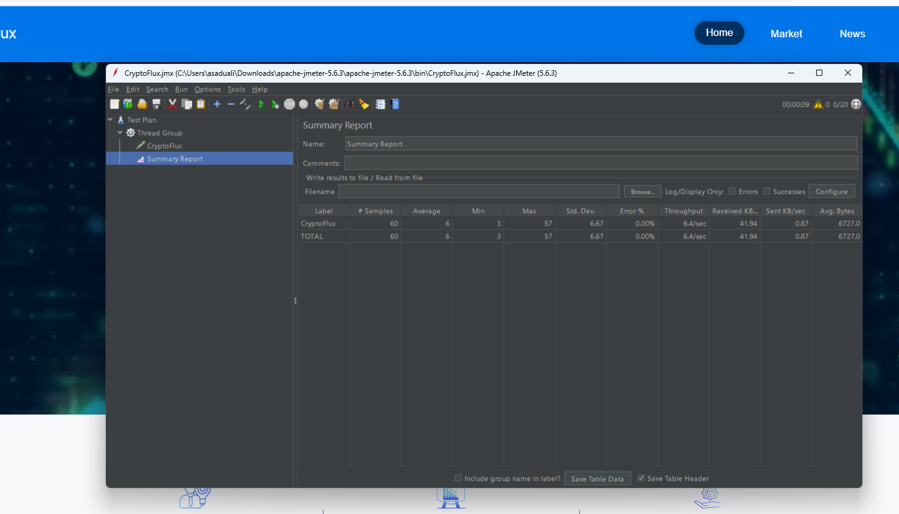
Task 2: Stress Test (Increasing Load)
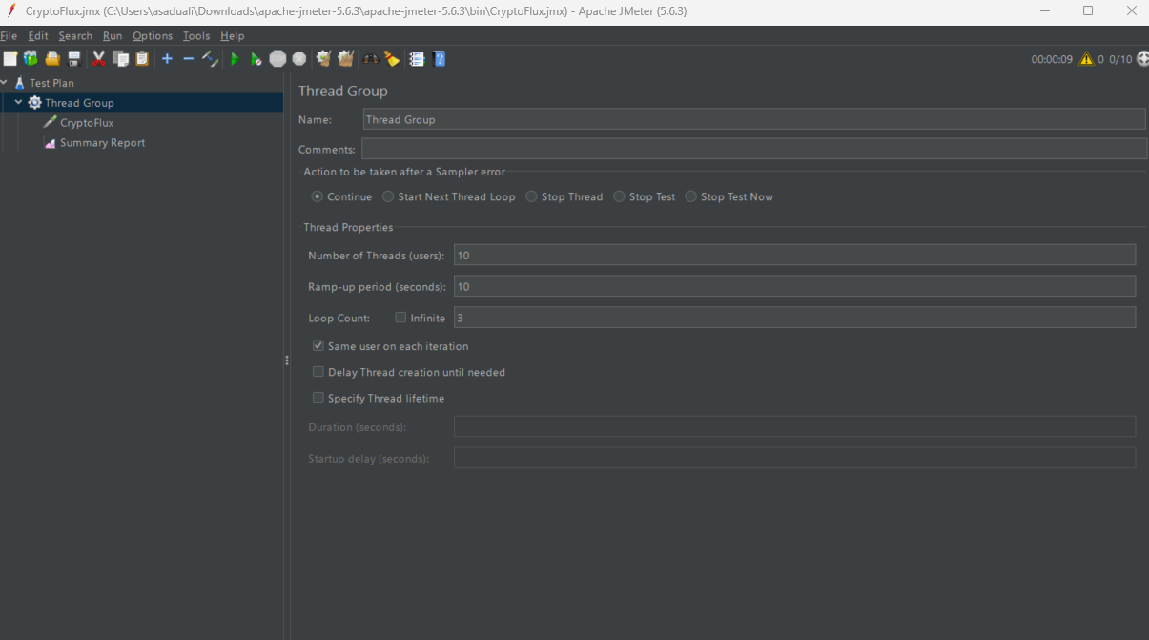
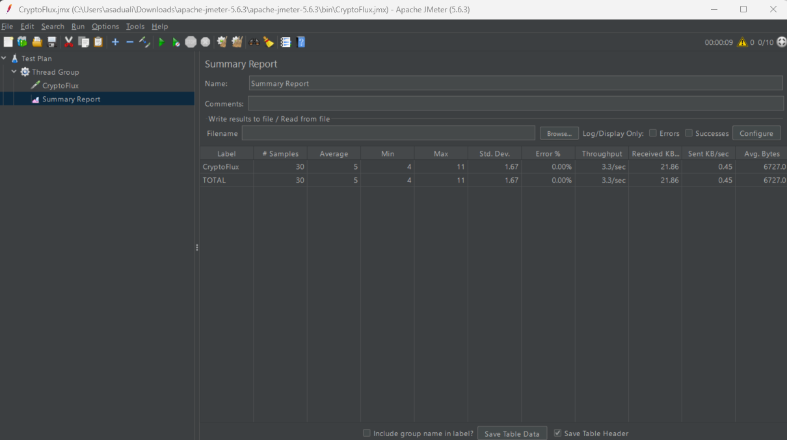
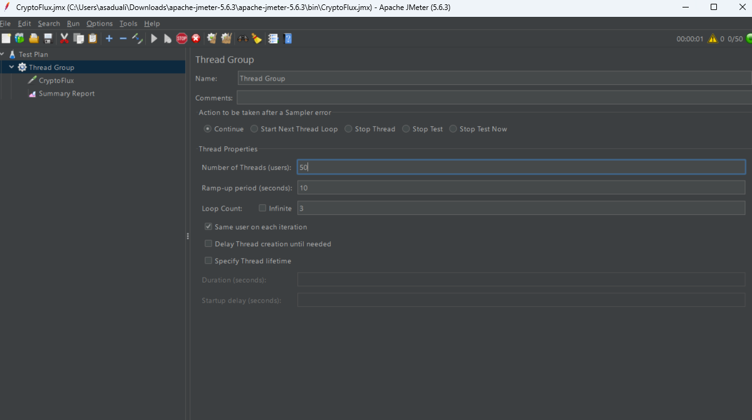

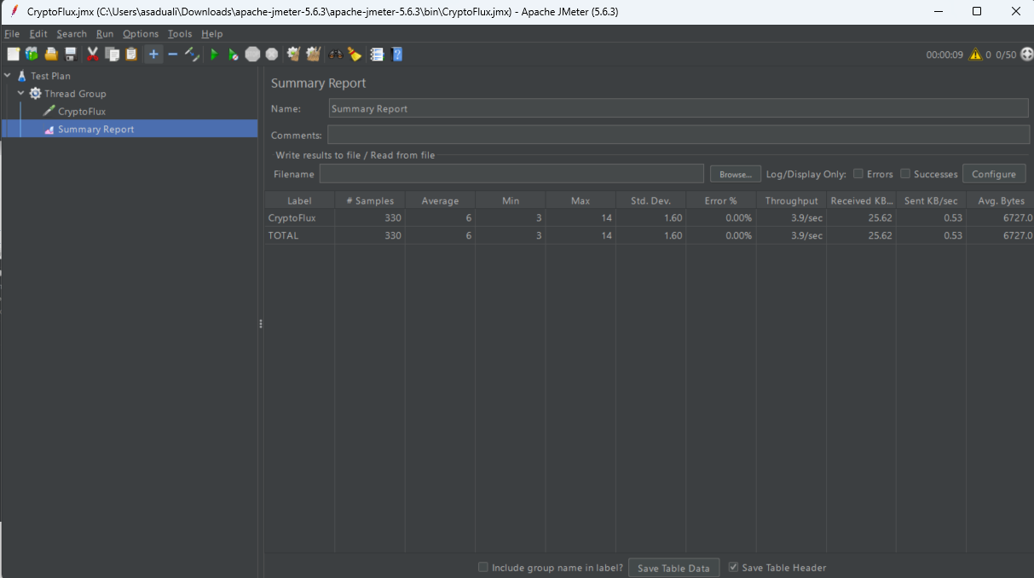

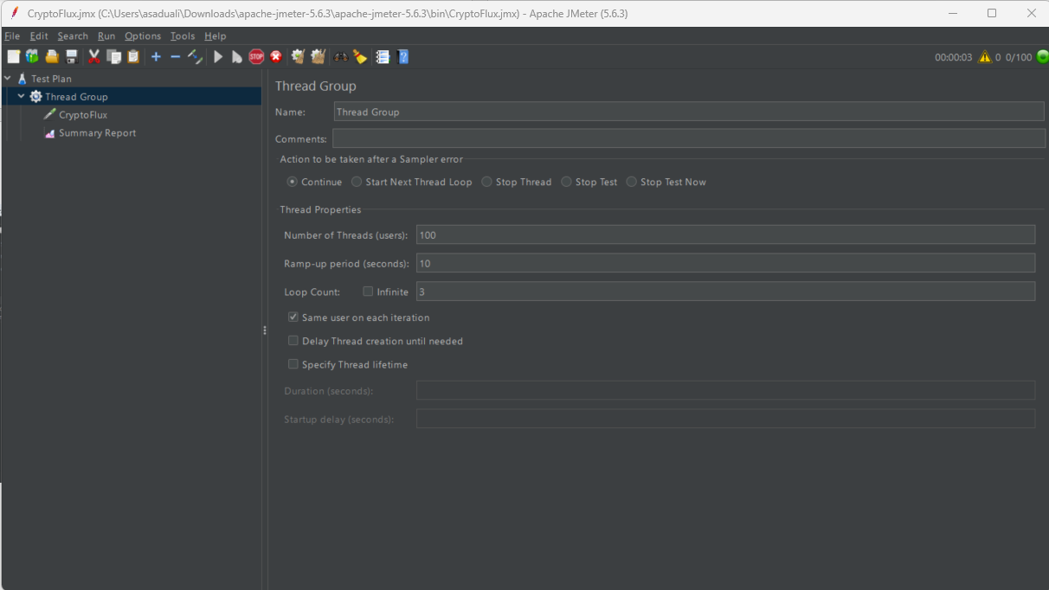

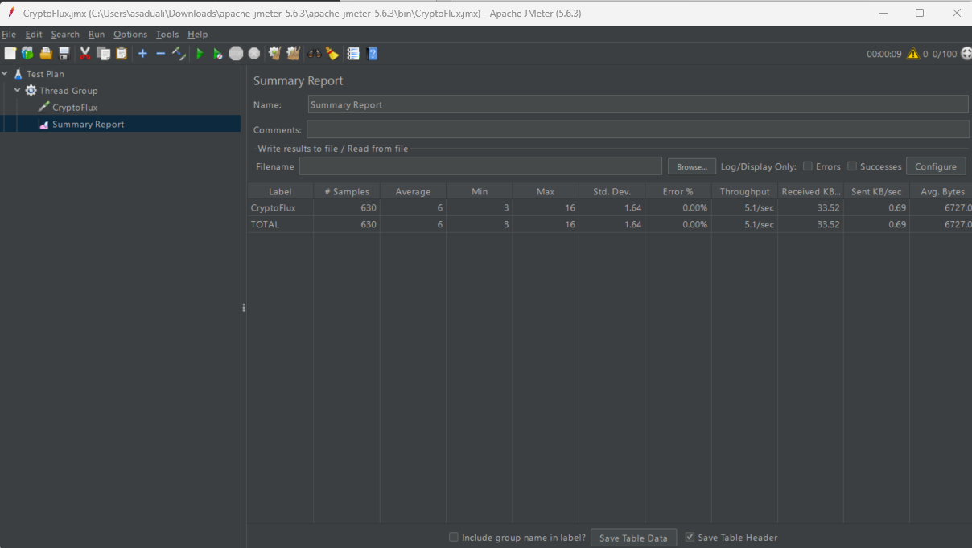

Task 3 Compare Endpoints

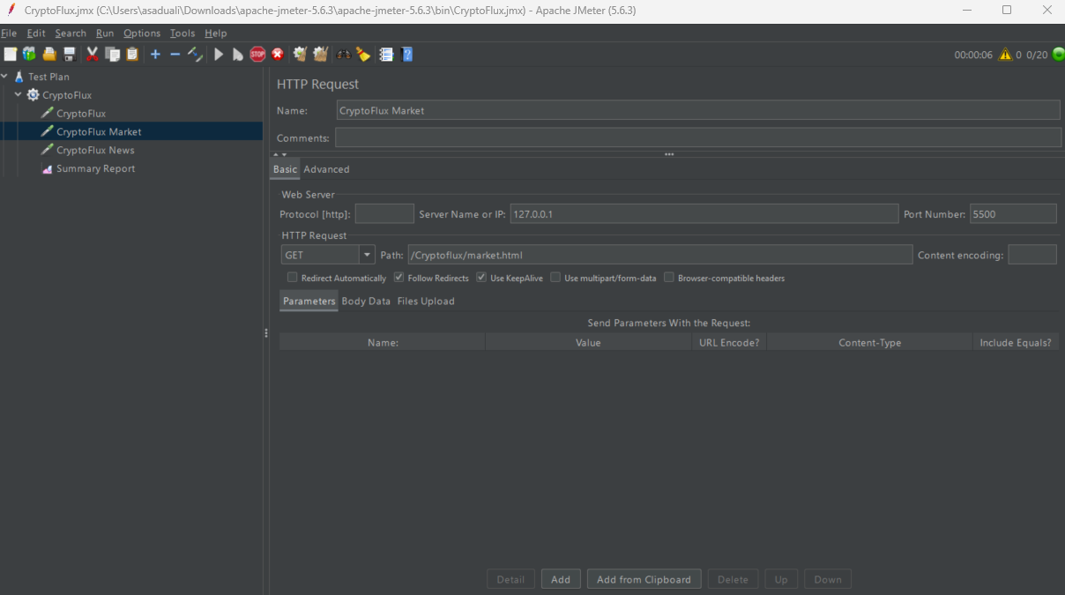
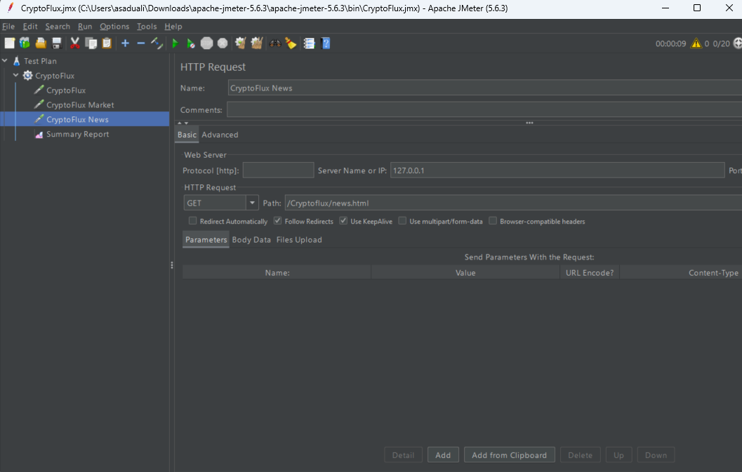

Summary Report:
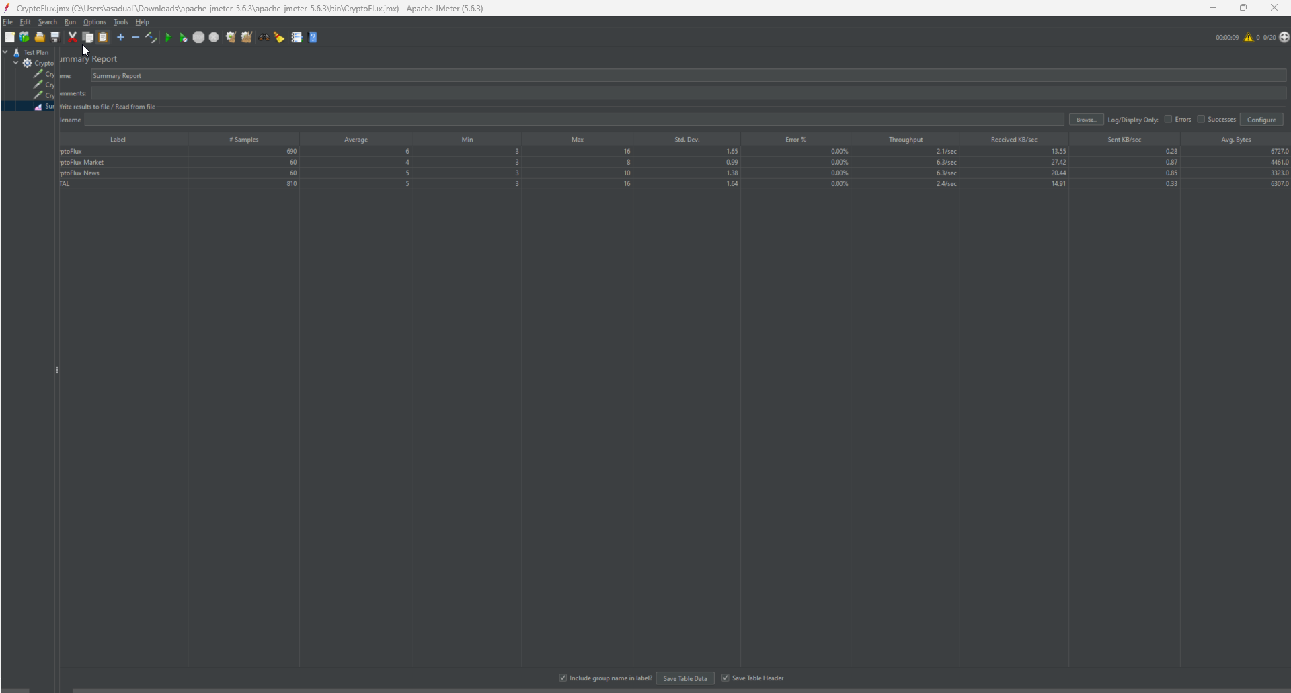

9. Analysis
As the user load increased from 10 to 100 users, the response time remained extremely stable (fluctuating only between 5 ms and 6 ms) and stayed well under the 2-second threshold. The throughput scaled successfully with the number of users, indicating the local Live Server efficiently handles simultaneous connections without dropping requests. When comparing endpoints, the Market page was the fastest (4 ms average), closely followed by the News page (5 ms), while the Home page averaged 6 ms. All endpoints performed exceptionally well with a 0% error rate across all stress levels.

10. Bottlenecks
No bottlenecks were observed during these frontend static file load tests. The Error Rate remained at 0% even under a 100-user stress test.

11. Recommendations
Because the local VS Code Live Server easily handled 100 users serving static HTML, the next phase of performance testing must target the live Python backend (MarketDataAPI and NewsAPI) to identify true database and data-fetching bottlenecks.

12. Conclusion
The frontend architecture of the CryptoFlux application demonstrates excellent performance and stability. It successfully handles simulated real-world traffic spikes, confirming the UI layer is fully optimized and ready for production-level backend integration.

